

LOGBOOK

BIT4107: MOBILE APPLICATION DEVELOPMENT
NAME: ANN NJERI MAINA
LECTURER: MICHAEL NYORO
SCHOOL: COMPUTING AND INFORMATICS
DEPARTMENT: INFORMATION TECHNOLOGY
COURSE: BACHELOR OF SCIENCE IN INFORMATION TECHNOLOGY

WEEK 4: INDUSTRY BASED PROJECT.
BUSINESS: EPIC READS.
BUSINESS OWNER: JAMES.
Problem
Customers must physically visit James' bookshop to see available books. They may also need to call James to ask whether a book is in stock and travel to the shop to inspect it before making a purchase. This is inconvenient, time-consuming, and can discourage potential customers.
Solution
EpicReads is a mobile application that allows customers to browse books, view prices, check availability, request books, reserve books, and place orders directly from their phones. James can easily manage books, prices, and customer requests through a simple dashboard.
Impact
- Customers can view available books from anywhere.
- Customers can request books that are not in stock.
- Customers can order or reserve books using their phones.
- Customers save time and transportation costs.
- James can reach more customers and increase book sales.

APPROVED DEMO AND PROTYPES FOR EPIC READS.
LOGIN PAGE
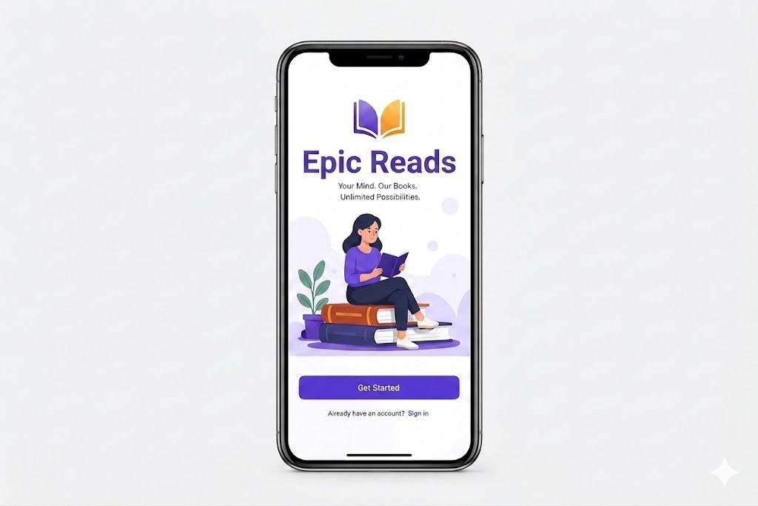

HOME PAGE
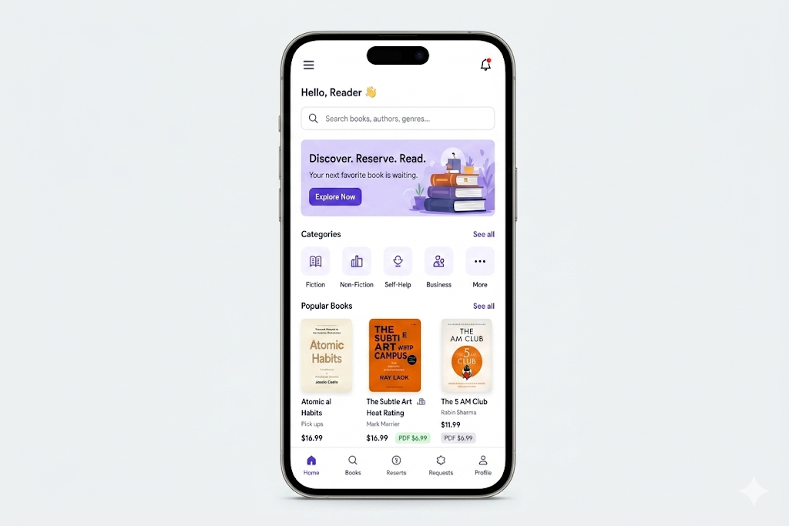

BOOK DETAILS
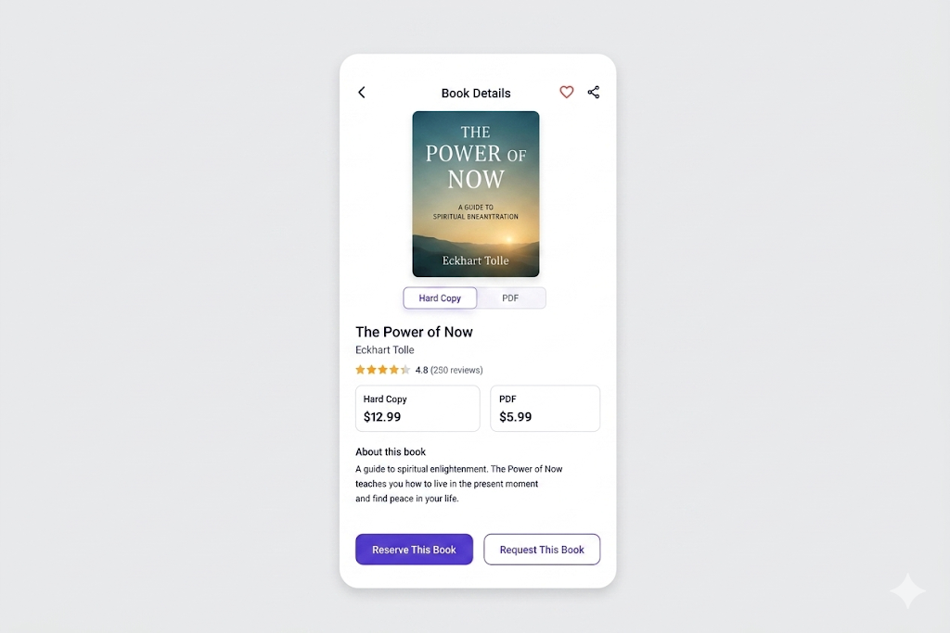

RESERVE A BOOK
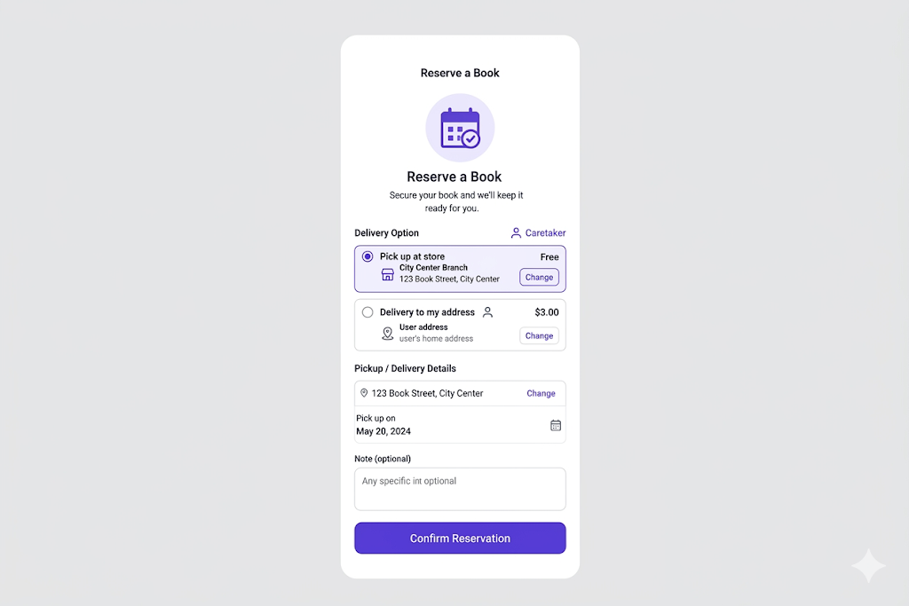

REQUEST A BOOK
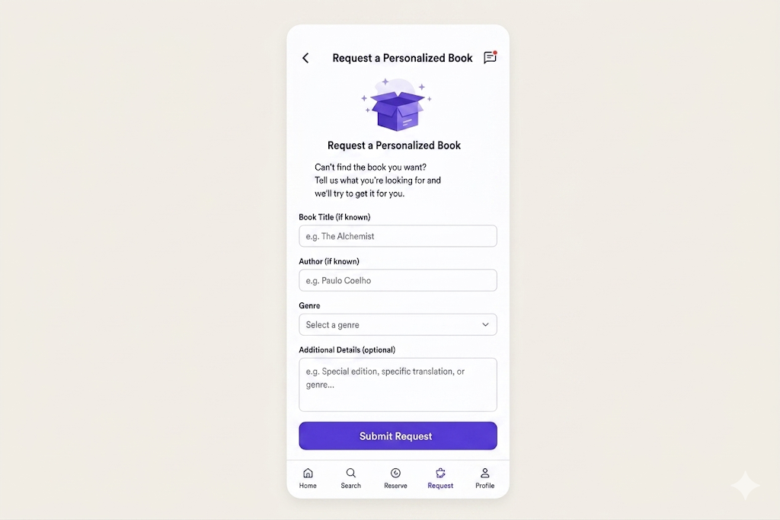

CHOOSE YOUR FORMAT
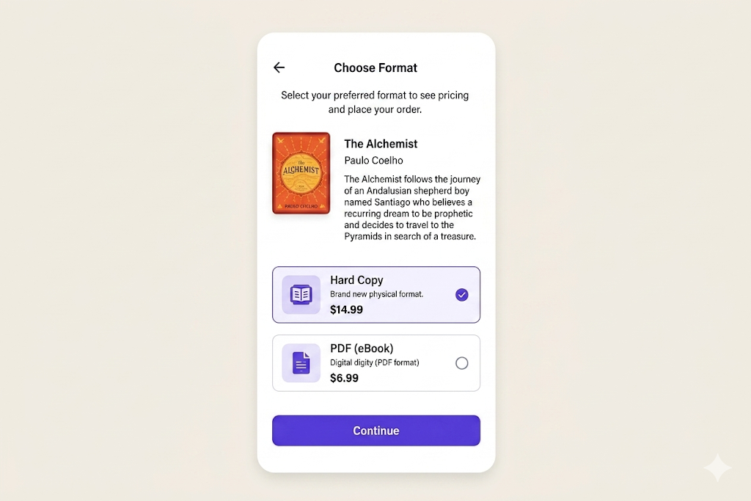

REQUEST SUBMITTED
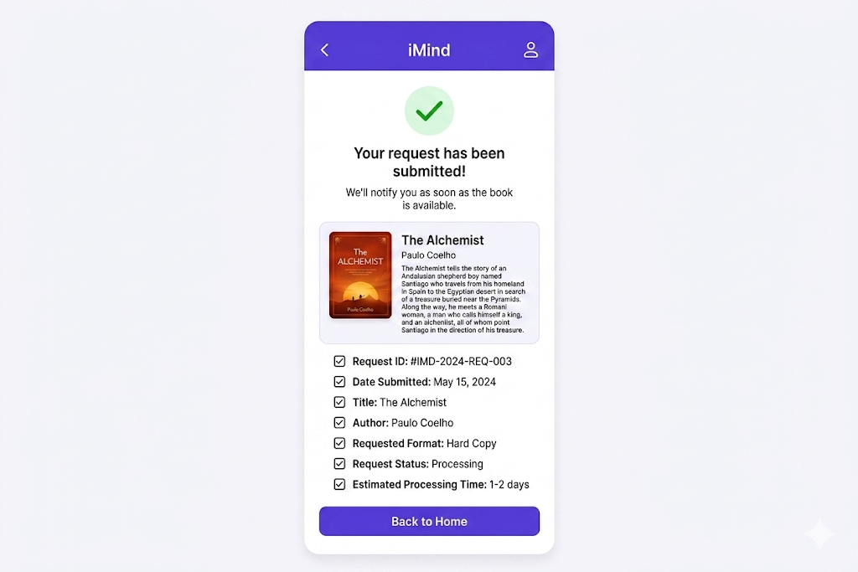

RESERVED BOOKS
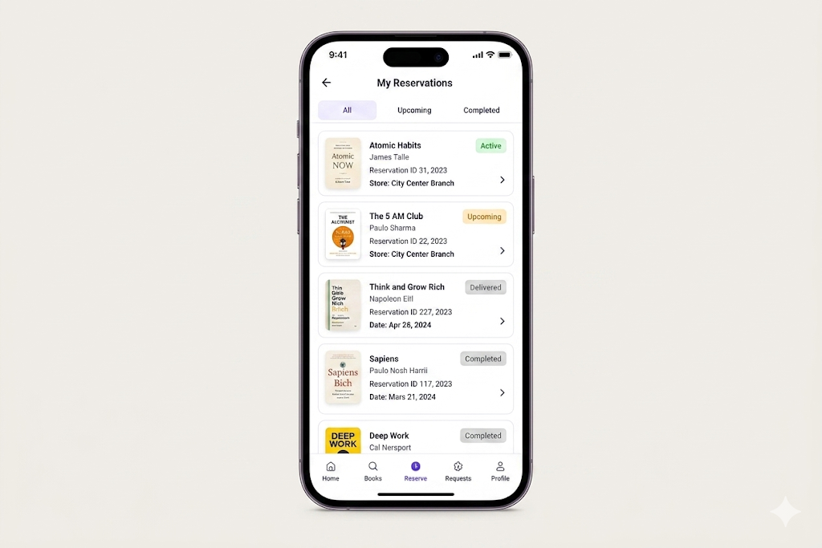

REQUESTED BOOKS
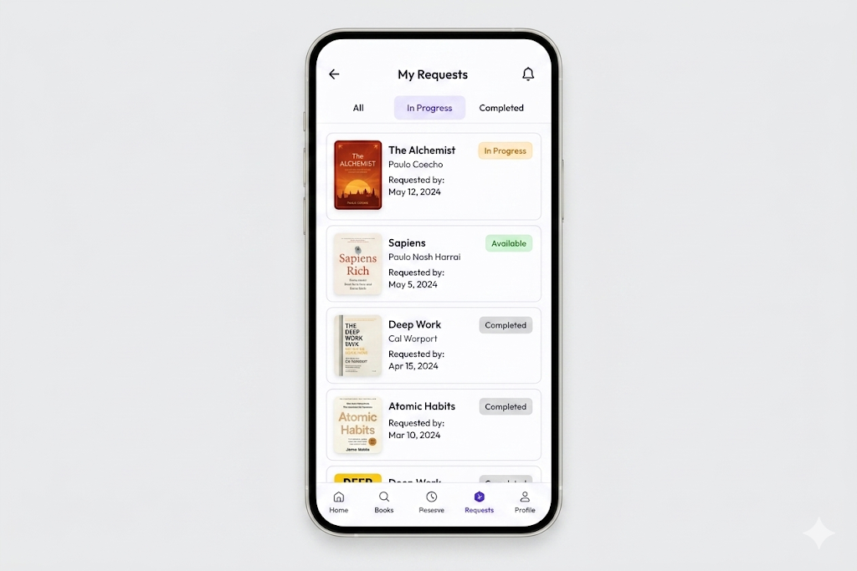

NOTIFICATIONS
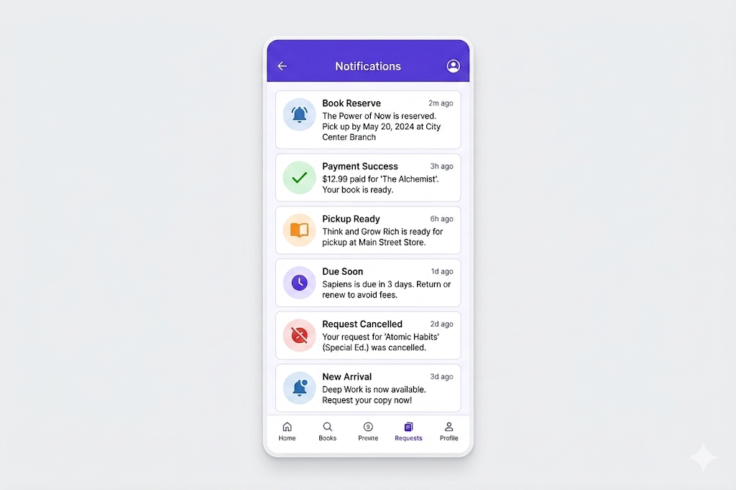

FIGMA PROTOTYPE

HOMEPAGE
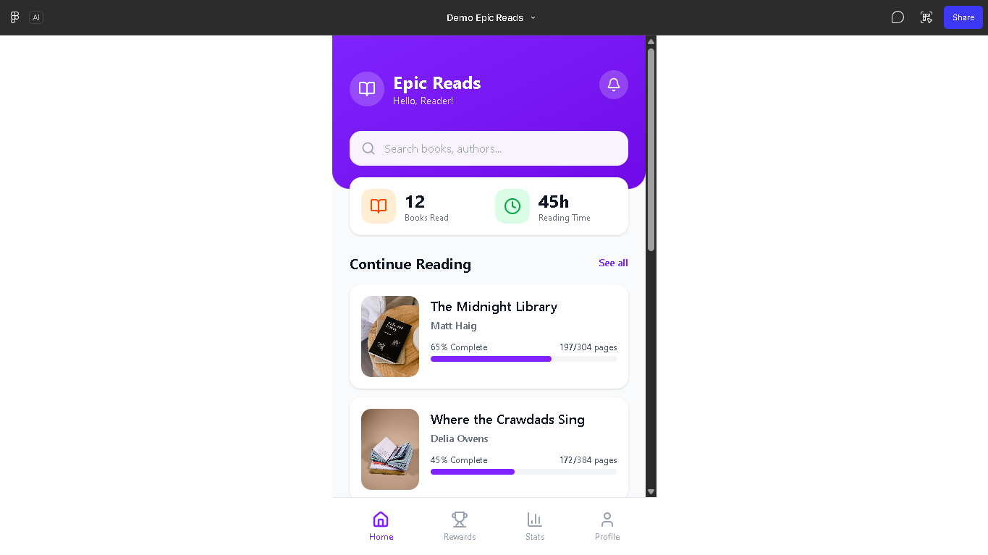

REWARDS PAGE
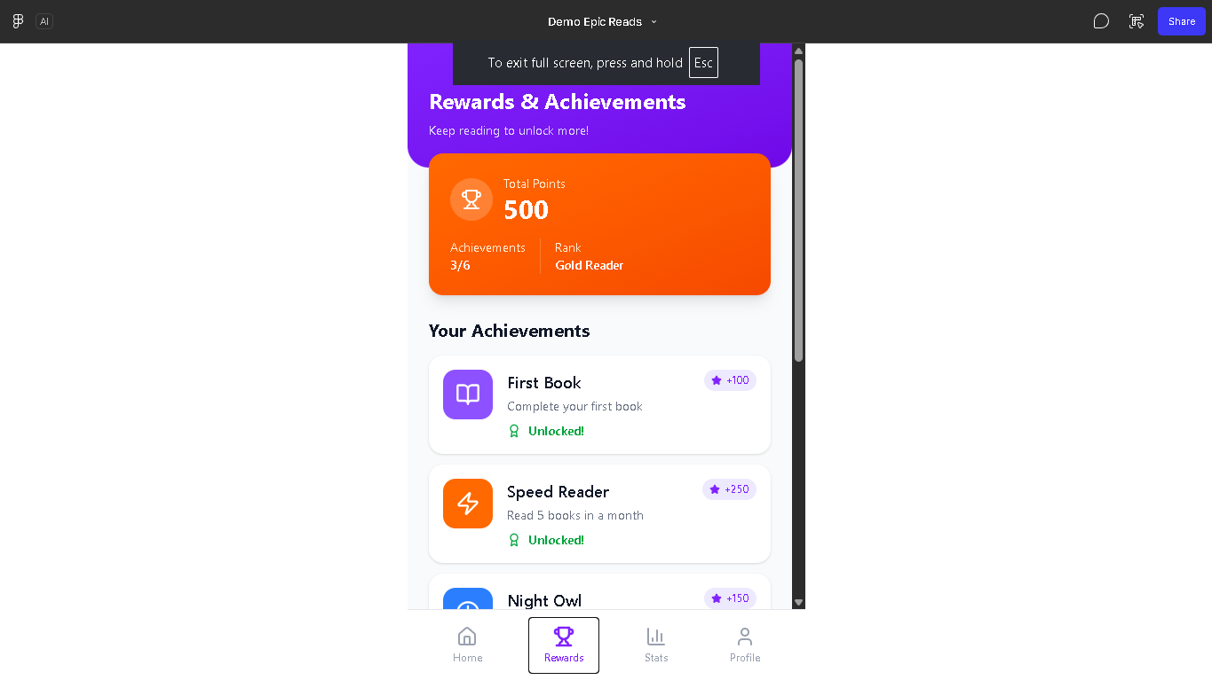

STATISTICS PAGE

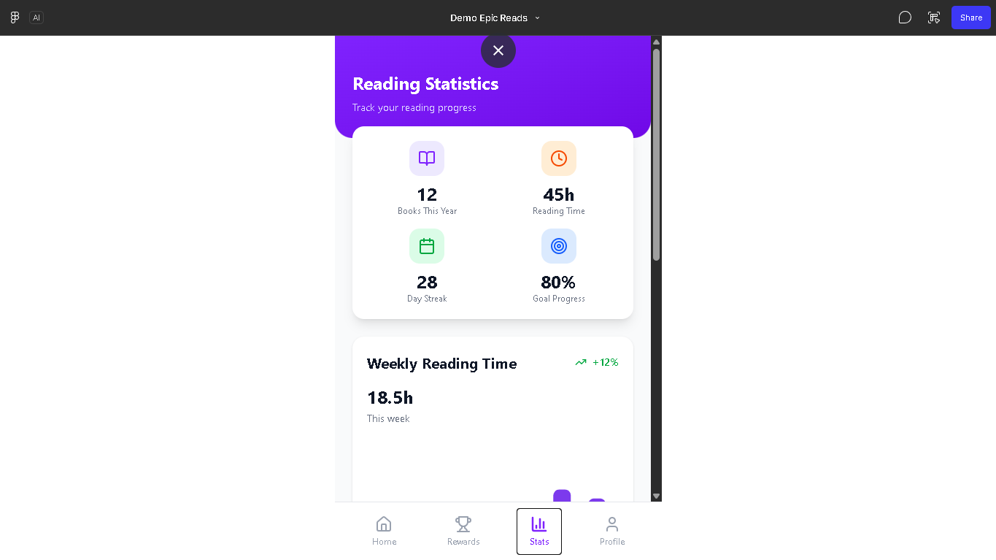
PROFILE PAGE
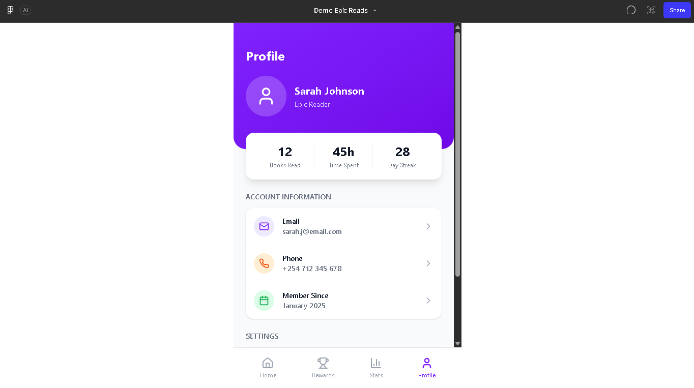

EPIC READS APP SIMULATOR
USER SECTION
The Login page
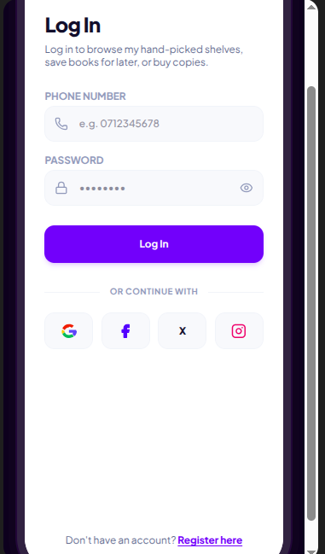

The Registration page
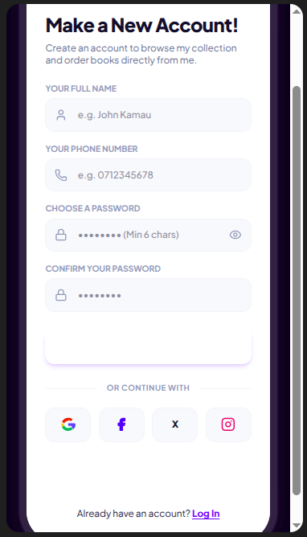

Global Library API catalogue
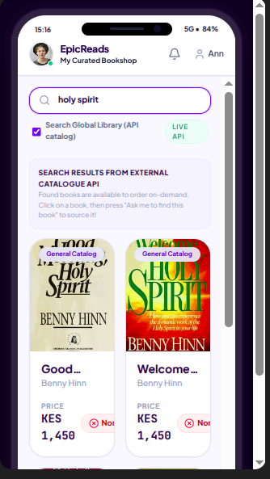

Welcome page
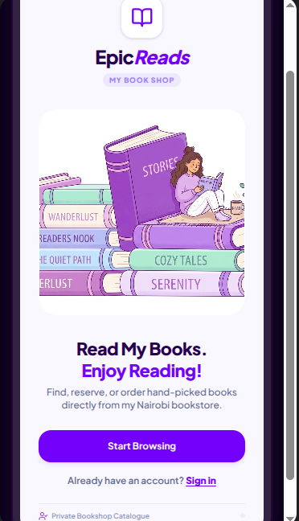

Account
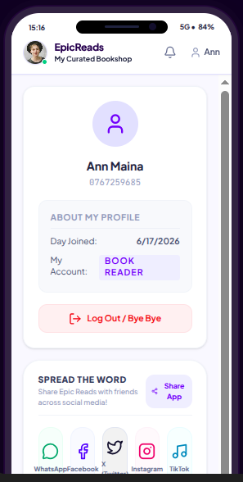

Activities
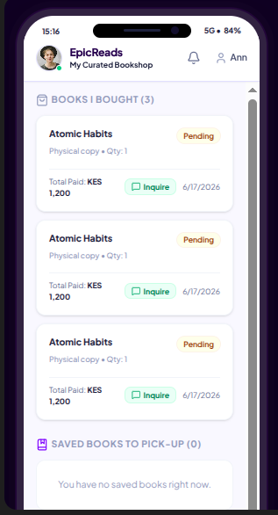

Request a Book
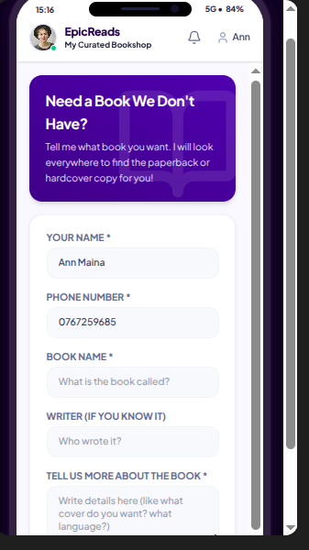

Dashboard
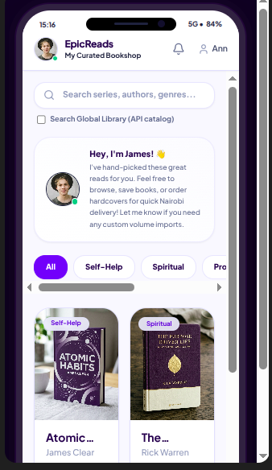

ADMIN SECTION
The Login page
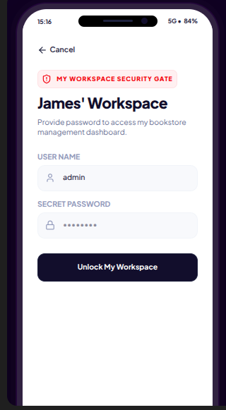

Updating/Deleting Books
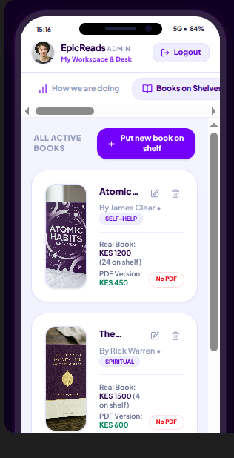

Read User details
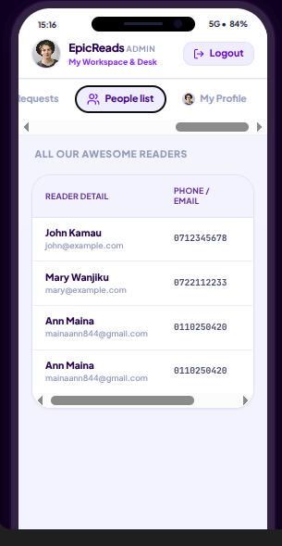

Profile
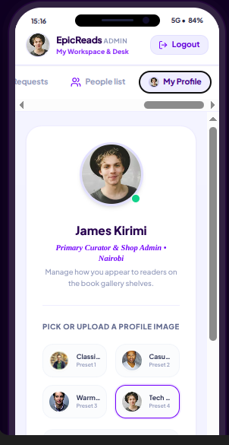

Dashboard
